**2-5 Milestone: Project Proposal**

Celine K. Philachanh

Department of Computer Science, Southern New Hampshire University

CS-330: Computer Graphics and Visualization

Professor Kurt Diesch

November 9, 2022

**Project Proposal**

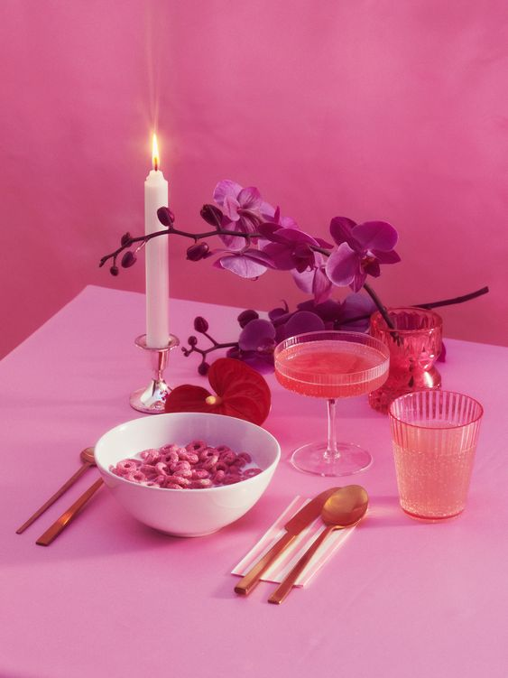

Above is the 2D image I wish to model. Of the items included in the image, the ones I will be creating in 3D are the bowl, spoon, napkin, coupe glass, candle holder and the candle stick. These are good choices for my work because they all vary in shapes and by recreating a 3D version of the objects in this 2D image, I can expand my understanding and practice on 3D representation. Additionally, with just these specific objects, the image can still be portrayed to the utmost accuracy to its 3D counterpart. The objects also range from simple to complex objects. The decision process of choosing this range was made because I want to be able to come face to face with a challenge and hopefully complete the challenge fully. To add on, the selected objects will still come together to recreate a 3D scene that is comprehensive for the image.

The bowl can be created using an upside-down pyramid while the spoon can be created using an elongated cube for the handle and a compressed sphere for the tip of the spoon. The spoon adds complexity to the image because it includes more than one primitive shape. For the napkin underneath the spoon, a plane or thinly and widely compressed cube can be used. As for the coupe glass I want to make 3D image pop out more and adding the coupe glass to the creation of the 3D image adds extra creativity. The shapes to be considered for the coupe glass are an upside-down pyramid, plane for the foot of the glass, and a cylinder for the handle of the glass. Finally, the candle holder and candle stick sounded like an interesting idea to recreate a 3D model of. To do so, I can use an elongated cylinder for the candle stick and two pyramids for the candle holder. As for the wick of the candle stick, a cylinder will be used. For the ground of the objects in the scene, I will be utilizing a plane to represent a table or base of the objects. Though I have selected more than four objects in my scene, I think it will be a fun and experimental way for me to gain exposure to various primitive shapes in the 3D structure of the 2D image.

The choices I made make sense because they all piece together and create an obvious scene that represents a dinner table with essential dining table items such as a bowl and spoon. The candle and coupe glass add more depth to the image. I will be able to accomplish the overall scope of the work by working on the more complex objects first then work my way down to the lesser complicated objects. Additionally, to ensure that the objects appear accurate to that of the 2D image, spending more time on the minute details will help combat any confusion between shapes and objects. With the chosen objects, I believe that they can be achieved even if they may take extra time and attention to detail. These objects are unique and appear exciting for me to analyze and explore.